Problem Solving

Portfolio 1

Contents

Assessment 1 : 3

Assessment 2: 5

Assessment 3: 6

Assessment 4: (for loop) 8

Assessment 5: and Independent research (Switch Statement): 9

Assessment 6: 12

Assessment 7 14

Assessment 8: 17

## Assessment 1 :

#include <stdio.h>

int main(void)

{

float mileage;//here I declared a variable called mileage that store the value of the distance, the type of the variable is float to store decimal numbers, I did the same for the cost but with the int type variable that only stores integers//

int cost;

printf("how many miles are you from the destiny? :\n");//printf is used to print to the console the statements tat are between the quotation marks//

scanf("%f",&mileage);//scanf is used to get inpout from the user and store it in to a variable, in this case the mileage variable//

printf("what is the value of your package? :\n");

scanf("%d",&cost);

printf("You paid: %d\n", cost);

printf("You are %.2f miles away\n", mileage);

if (mileage < 10 && cost >= 100)// the if statements allow me to make a condition and if the condition is fulfilled the program executes what is indented bellow, in this case, "mileage = 0". the && allow me to do the and statement so, the condition above in the, if can be read as mileage, is less than 10 and the cost is bigger or equal to 100 //

{

mileage = 0;

}

else if ( mileage < 10 && cost < 100)// the else if statement is used to put another condition in the program//

{

mileage = 5;

}

else if (mileage < 20)

{

mileage = 10;

}

else if (mileage < 30)

{

mileage = 20;

}

else//the else statement is normally used in the last condition of the program and the target is everything that is not conditioned//

mileage = (mileage - 30)* 0.5 + 30 ;//I used this simple math to allow me to add an extra 50p for each extra mile//

printf("The delivery fee is: %.2f\n", mileage);// the %f is to declare where the float variable that is out of the quotation marks should be placed//

printf("The total cost is: %.2f\n", mileage + cost);

}

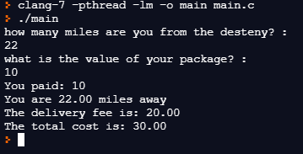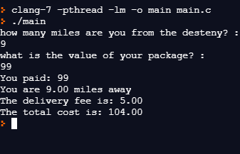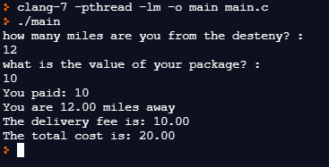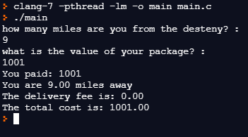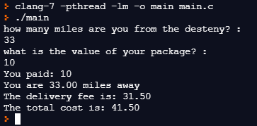

## Assessment 2:

#include <stdio.h>

int main(void)

{

printf ("please enter a number between 1-20: \n");

int numb;

int l = 1;

scanf("%d", &numb);

if (numb > 20)

printf ("Sorry, the number needs to be between 1 and 20");

else

{

while (l <= 20)//the while function is called a loop

because it will only get out of the loop when the condition between parentheses is fulfilled//

{

printf("-");

if (l == numb)

{

printf("X");

l++;//I used the l++ to replace the - that wase supposed to be there//

}

l++;//I used the l++ to add 1 to the variable l every time that the loop repeat

}

}

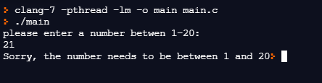

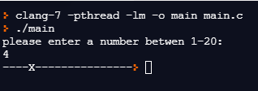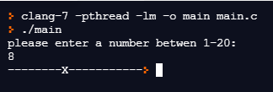

## Assessment 3:

#include <stdio.h>

#include <stdbool.h>

int main(void)

{

while (true)//this while is responsable to not let the program end until get a response that coresponds as false(in this case return 0, becouse 0 == false )this part is in the x case

{

printf("Please enter the letter which corresponds with your choice: \n a – Calculate the area of a rectangle \n b - Calculate the area of a circle \n c – Display a multiplication table \n d – Add two numbers\n x -Exit program\n");

char letter;

printf("insert your leter: \n");

scanf(" %c",&letter);

switch(letter)//this switch stament aloow the program to no wht bok of code is going to execute depending on the value of the variable letter

{

case 'A':case 'a':

{

float width;

float height;

printf("insert the width: \n");

scanf("%f", &width);

printf("insert the height: \n");

scanf("%f", &height);

printf("the area of the rectangle is: %.2f\n",width*height);

break;

}

case 'b': case 'B':

{

float radius;

printf("insert the circle radius: \n");

scanf("%f", &radius);

printf("the area of he circle is: %.2f\n",radius*radius*3.14);

break;

}

case 'c': case 'C':

{

int tabuada;

int numb = 1;

printf("insert the number for the multiplication table: \n");

scanf("%d", &tabuada);

while (numb <= 10)

{

printf("%d\n",tabuada*numb);

numb++;

}

break;

}

case 'x' :case 'X':

{

return 0;

}

default:

printf("plese enter a valid letter\n");

}

}

}

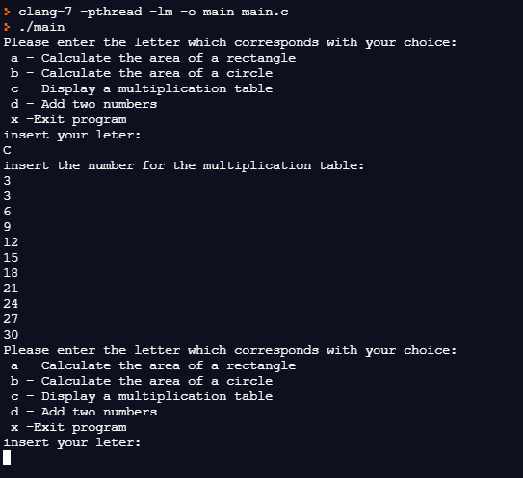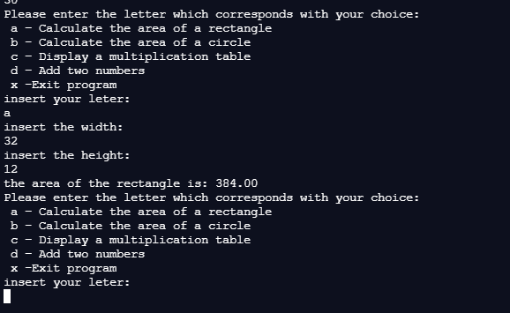

## Assessment 4: (for loop)

#include <stdio.h>

#include <stdbool.h>

int main(void)

{

int i , t , X, Y;

printf("enter the row: \n");

scanf("%d", &X);

printf("enter the column: \n");

scanf("%d", &Y);

if (X > 10 || Y > 10)//I used this if statement to delivery an error message in case of x or y be bigger than 10

{

printf("please, the numbers for the row and column should be between 0 - 10");

}

else

{

for (i = 1; i < 11; i++)//the for loop is used to execute a specific number of times, in this case until i < 11 I put i starting as 1 because I assume that the input from the user starts at 1.this for is responsible to print the enters until the count of i is equal to 10

{

for (t = 1 ; t < 11; t++) //this for loop is responsible for printing the dashes

{

if (X == i && Y == t)//this if statement is responsible for replace one dash by a x in the coordinates that the user input in x and y

{

printf("X ");

t++;

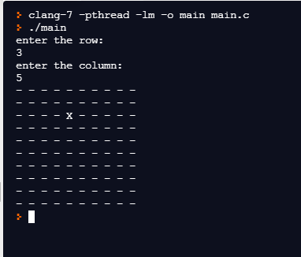 }

printf("- ");

}

printf("\n");

}

}

}

## Assessment 5: and Independent research (Switch Statement):

#include <stdio.h>

#include <stdbool.h>// i included this library to be able to use bolean signals

int main(void)

{

char letter;

int numbers[100] = {};

int count = 0;

int n;

printf("please enter the size of the string(must be under 100)");

scanf("%d", &n);//this scanf determinate the size of the string

if (n < 100)

{

while(count < n)//this whille is responsable to get input of the values form the user to put in the sting

{

printf("please enter valiues to the string\n");

scanf(" %d", &numbers[count]);

count++;

}

}

else

printf("please enter a number betwen 0-100");

while(true)//this while is responsable to not let the program end until get a response that coresponds as false(in this case return 0, becouse 0 == false )this part is in the x case

{

printf("Please enter your choice from the following menu:\nA – Repopulate array\nB - Display all values\nC – Replace one number\nD – Calculate the mean\nE – Find largest number\nX - End the program\n");

scanf(" %c" ,&letter);//the scanf is responsable to read the input that the user select form the menu

switch (letter) //the switch stament is reponsable to determinate what the program will do depending from the input from the user

{

int count_1 = 0;

case 'a':case 'A': //case the input is a or A this part f the code will execute, if not it will move to the next case untill arrive to the defoult case

{

int count_4 = 0;

while(count_4 < n)//this whille is responsable to Repopulate the array by recive a input from a user overwriting the value in the position count_4 that is alwas increentatintig

{

printf("please enter valiues to the string\n");

scanf(" %d", &numbers[count_4]);

count_4++;

}

break;//this brake alow the function to end and dont proced to the next case

}

case 'b':case 'B':

{

int count_2 = 0;

while (count_2 < count)//this whille is just used to force the array number to incrementate untill reach the end of the arraye (the null terminator \0)

{

printf("%d\n", numbers[count_2]);

count_2++;

}

break;

}

case 'c': case 'C': //simple code to overwrite a value from the array the position of the value is selected by the user in the variable place

{

int place;

int new_number;

scanf("%d",&place);

scanf("%d",&new_number);

numbers[place] = new_number;

break;

}

case 'd': case 'D':

{

float totalage= 0.0;

int count_3 = 0;

while (count_3 < count)// this while is used to store the value of the sum of all ages in the variable totalage

{

totalage += numbers[count_3];

count_3++;

}

printf("the mean is : %.2f\n", totalage / n);

break;

}

case 'e':case 'E':

{

int max_numb;

int i;

max_numb = numbers[0];

while (i < n) // this whille is used to see all numbers in the array and stor the bigest in the variable max_numbers

{

if (numbers[i] > max_numb)

max_numb = numbers[i];

i++;

}

printf("the largest number is%d\n", max_numb);

break;

}

case 'x':case 'X':

{

return 0;

}

default: //in case of none of the situation is coverd the progeam will execute the default , in this case print: "please chose a letter form the menu"

{

printf("please chose a letter form the menu\n");

}

}

}

}

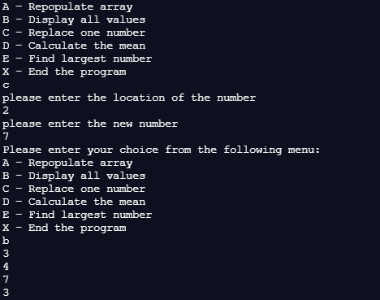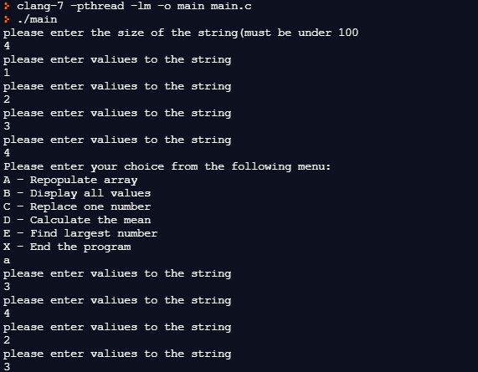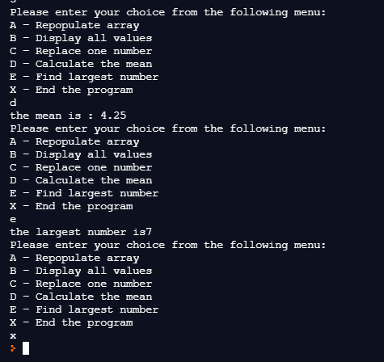

## Assessment 6:

#include <stdio.h>

#include <stdbool.h>

int main(void)

{

int swapped , count , swap;

int broo[5] = {6,5,3,1,2};

printf("the original stirng is:\n");

for (count = 0 ; count < 5 ; count++)

{

printf("%d\n", broo[count]);

}

while (1)// this whille force the for loop to repat to order every sigle value in the array and not just the first

{

swapped = 0;

for (count = 0 ; count < (4) ; count++)// this for loop allow to organize the value in position 0 of the array

{

if (broo[count] > broo[count + 1])

{

swap = broo[count + 1];

broo[count + 1] = broo[count];

broo[count] = swap;

swapped = 1;

}

}

if (swapped == 0)// allow to get out of the while loop

{

break;

}

}

printf("\nthis is the ordered string :\n");

for (count = 0 ; count < 5 ; count++)//prints the array

{

printf("%d\n", broo[count]);

}

}

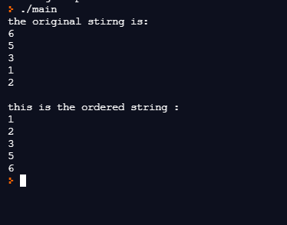

## Assessment 7

#include <stdio.h>

#include <stdbool.h>

int case_a(float x , float y)//used a function calesd case a to store this part of the program

{

printf("insert the width: \n");

scanf("%f", &x);

printf("insert the height: \n");

scanf("%f", &y);

printf("the area of the rectangle is: %.2f\n", x*y);

return 0;

}

int case_b(float x)//used a function calesd case_b to store this part of the program

{

printf("insert the circle radius: \n");

scanf("%f", &x);

printf("the area of he circle is: %.2f\n",x*x*3.14);

return 0;

}

int case_c(int x, int y)//used a function calesd case_c to store this part of the program

{

y = 1;

printf("insert the number for the multiplication table: \n");

scanf("%d", &x);

while (y <= 10)

{

printf("%d\n",x*y);

y++;

}

return 0;

}

}

int case_default()//used a function called case_default to store this part of the program

{

printf("plese enter a valid letter\n");

return 0;

}

int main(void)

{

while (true)

{

printf("Please enter the letter which corresponds with your choice: \n a – Calculate the area of a rectangle \n b - Calculate the area of a circle \n c – Display a multiplication table \n d – Add two numbers\n x -Exit program\n");

char letter;

printf("insert your leter: \n");

scanf(" %c",&letter);

switch(letter)

{

case 'A':case 'a':

{

float width;

float height;

case_a(width , height);// called case_a to execute

break;

}

case 'b': case 'B':

{

float radius;// called case_a to execute

case_b(radius);// called case_b to execute

break;

}

case 'c': case 'C':

{

int tabuada;

int numb = 1;

case_c(tabuada,numb);// called case_c to execute

break;

}

case 'x' :case 'X':

{

return 0;

}

default:

case_default();// called case_default to execute

}

}

}

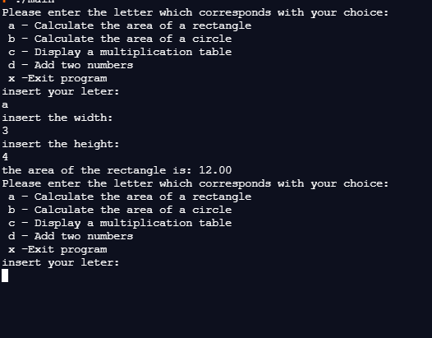

## Assessment 8:

Self-evaluation :

For this final task, I will write a self-evaluation about my experience during this unit, about what I learned of the programing language C and the biggest challenges that I have to do overcome while doing the assessments.

In this unit, a learned how to build and run any basic programs in C language, learn what variables, what kind of variables exist, and how much space they allocate in memory for each type of variable. The type of loops that exists and which one is more suitable for each occasion(while, for, do-while loops ) and do to independent research I learned a lot of very useful statements like the for loop and the switch statement. I realize that we will always be learning and that there is a lot of funny things we can do with a bunch of simple code lines. I loved the experience so much that this summer I will take a course at the 42 schools.

But the principal thing I learned is that for programing it is mandatory hours and hours of research, and sometimes the minimum mistake can make the whole code crash, so all attention is needed and mandatory while coding. A lot of coffee and time was needed so I was able to complete all the assessments. But I enjoyed it because of the feeling that in the end a got wen seeing all code running smoothly.

In conclusion I learned a lot during this unit and I loved the experience, I am thrilled with the idea of having more programing lessons next year independently of be in another language. I am going to start learning about python to be ready for a excellent first year of university.